Allison O’Donnell

David Campos

CM385-02

03/26/2020

User testing results summary

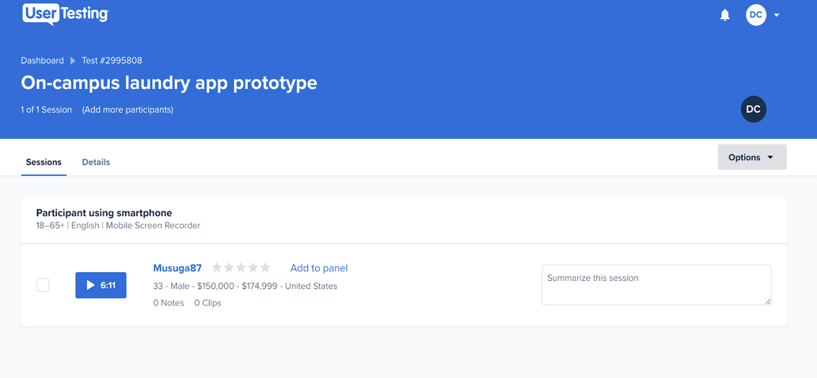One of the user testers of the app prototype found that this prototype was helpful for college students when doing their laundry. He thought it was a good concept. This user tester liked the fact that you can reserve a machine ahead of time. He also liked the delivery feature on the app, that it can be tracked on the map.

Link to the user-testing video: <https://app.usertesting.com/v/7c1f1e9f-a28b-4303-b761-1ae05fe82006?encrypted_video_handle=51a97e84-9a61-40c1-bd18-3db7a9039a96&shared_via=link>

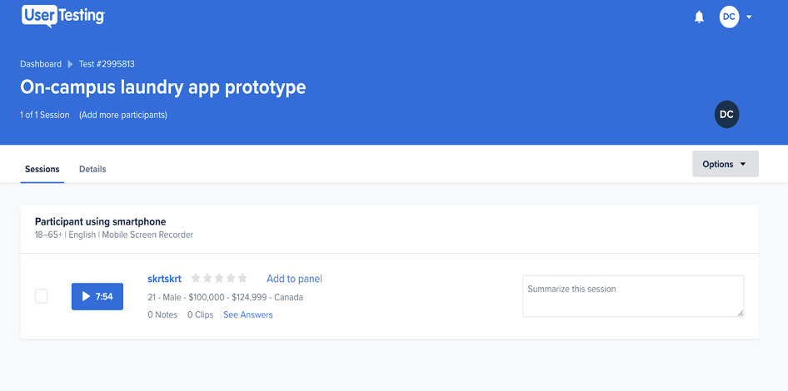Another user tester also liked that you can reserve machines through the app. He liked that it was very simple and straightforward with the different features it offers. However, he didn't like the timer feature. He said, “It should be a digital timer, and would be useful if it could tell u “10mins left you should leave now” based on GPS location.” He also thought the calendar feature wasn’t helpful just like the one on smartphones. On what to improve, he recommended to sync the timer with GPS location.

Link: <https://app.usertesting.com/v/ac47bd75-9de6-448c-b67c-fcd29da5437e?encrypted_video_handle=a0ff6a9f-26bf-4479-9f56-fe071218561e&shared_via=link>

Another user also liked this user-friendly app. He wasn’t sure if it was completely necessary to have a separate laundry app and thought it could be included in the university app itself. He thought the track delivery was a neat feature. He suggested that for the calendar feature, to have an option to delete a note/edit it. He said there was no way to check off that a task has been completed or a way to remove notes that have already been completed. He also 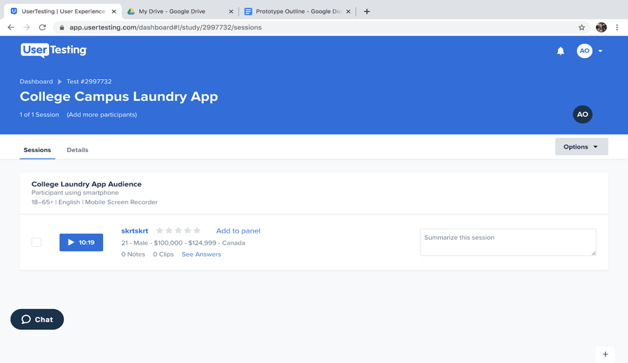thought the time should not only notify when the machine is done, it should also notify when there are 5-10mins left to account for travel time. Overall, he liked that the app is very simple to use, and it would be hard to get confused in the app. He gave the prototype a 9 out of 10 recommendation.

Link: <https://app.usertesting.com/v/e86135e0-1bae-4ad3-9cea-66b888ad1ca1?encrypted_video_handle=7037c459-9069-4cc3-861f-8940982b4adf&shared_via=link>

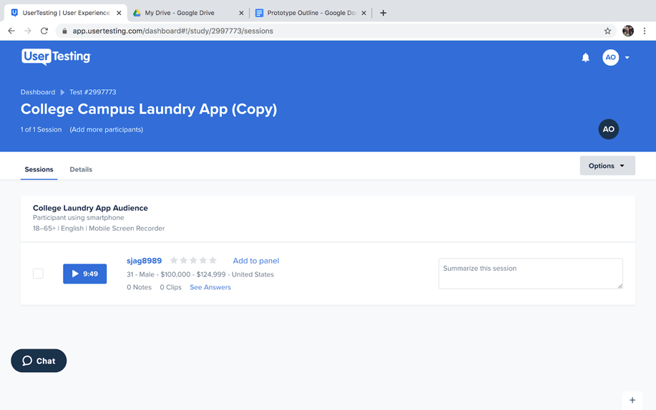The last user was very simple and to the point with his comments. He thought the app seemed very intuitive and straightforward and didn’t think he would be confused about anything. He said he would’ve appreciated something like this back when he was in school. He said really not much at all frustrated him about the app. He did say that the on/off toggle on the location services screen felt backwards and that the “on” button should be on the right and the “off” button should be on the left. He also said maybe to get rid of the calendar feature and didn’t think it was completely necessary to have a calendar to remind him when to do laundry, but also said it couldn’t hurt to have that feature. He liked how the timer synched to the washer and dryer machines and the option to pay for laundry within the app. He also thought it was cool how the app saved the user’s information and that user doesn’t have to retype everything. He gave this app a 10 out of 10 recommendation.

Link: <https://app.usertesting.com/v/4b4a8ab7-adc3-49af-9d77-fde6112b49ae?encrypted_video_handle=6b16cbdd-2f46-4850-9dd4-93a8c35d5a45&shared_via=link>